HADOOP_HOME= /home/hdoop/hadoop-2.10.1

$ HADOOP_HOME/etc/hadoop

/home/hdoop/hadoop-2.10.1/etc/hadoop

$ HADOOP_HOME/sbin

Public IPv4 DNS:ec2-3-137-151-17.us-east-2.compute.amazonaws.com

ubuntu@ip-172-31-45-16:/usr/lib$ echo $JAVA_HOME

ubuntu@ip-172-31-45-16:/usr/lib$ cd /usr/lib/jvm/

ubuntu@ip-172-31-45-16:/usr/lib/jvm$ ls

default-

java-1.11.0-openjdk-amd64 java-11-openjdk-amd64 openjdk-11

export JAVA_HOME=/usr/lib/jvm/java-11-openjdk-amd64

Go to my db1:

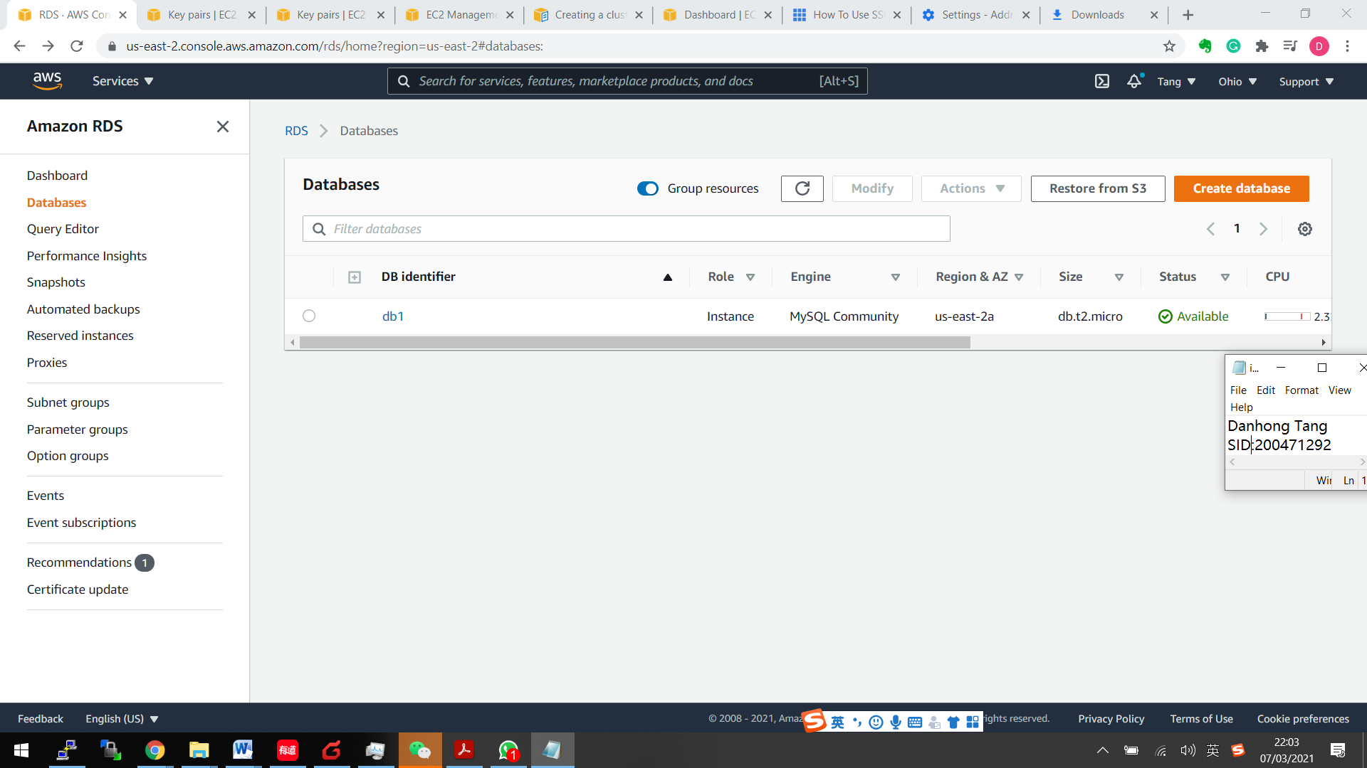

Choose an AMI with Ubuntu Server 18.04 LTS (HVM), SSD Volume Type:

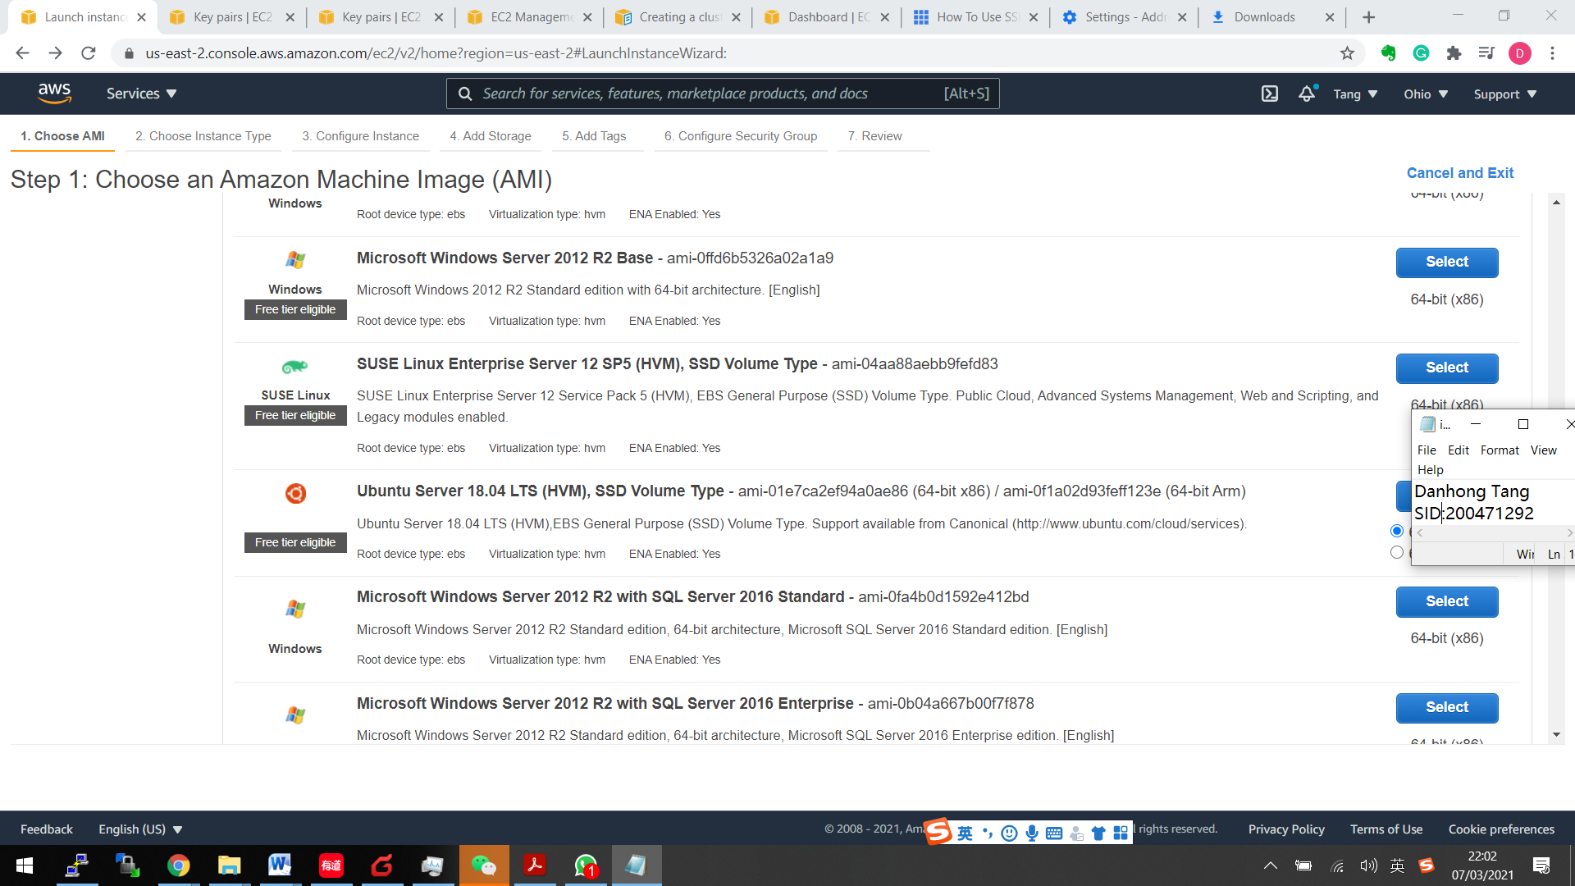

Create an instance:

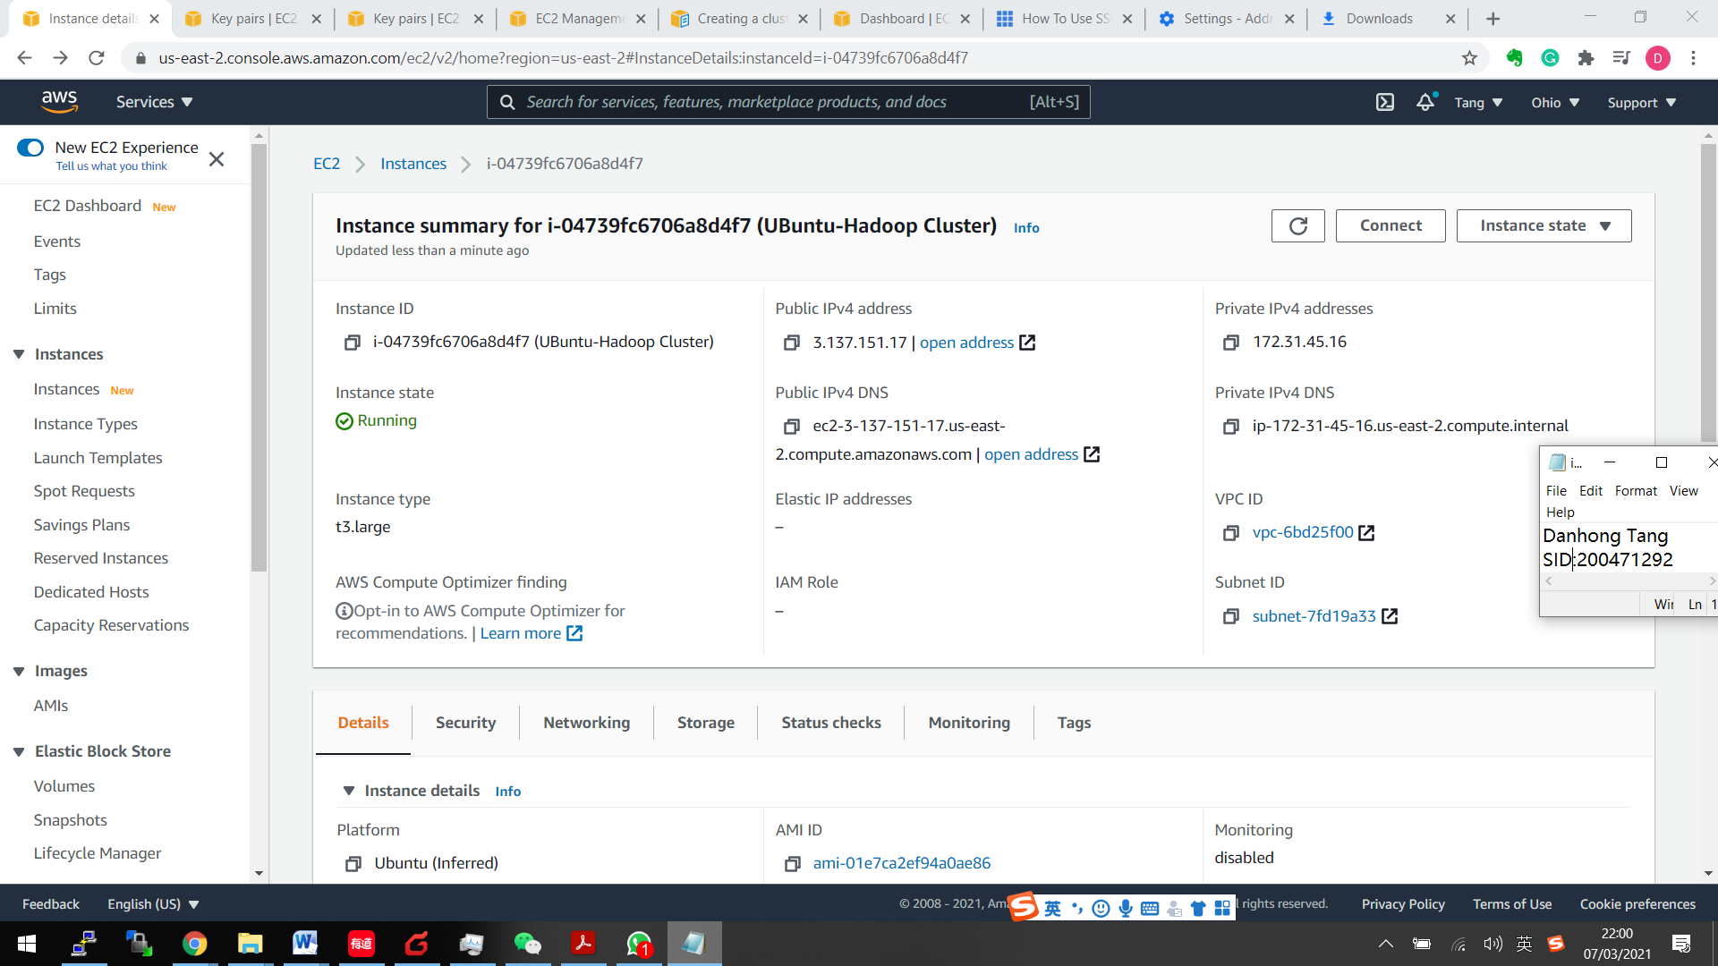

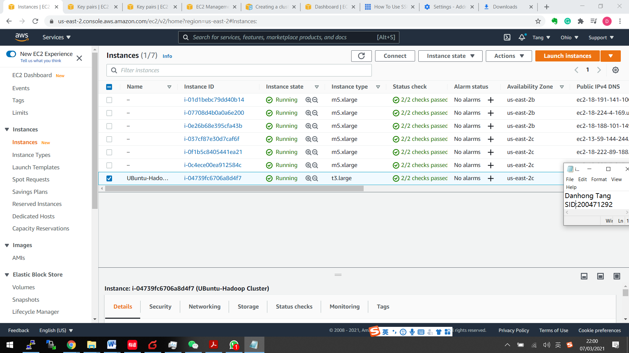

Connect to Putty using this info:

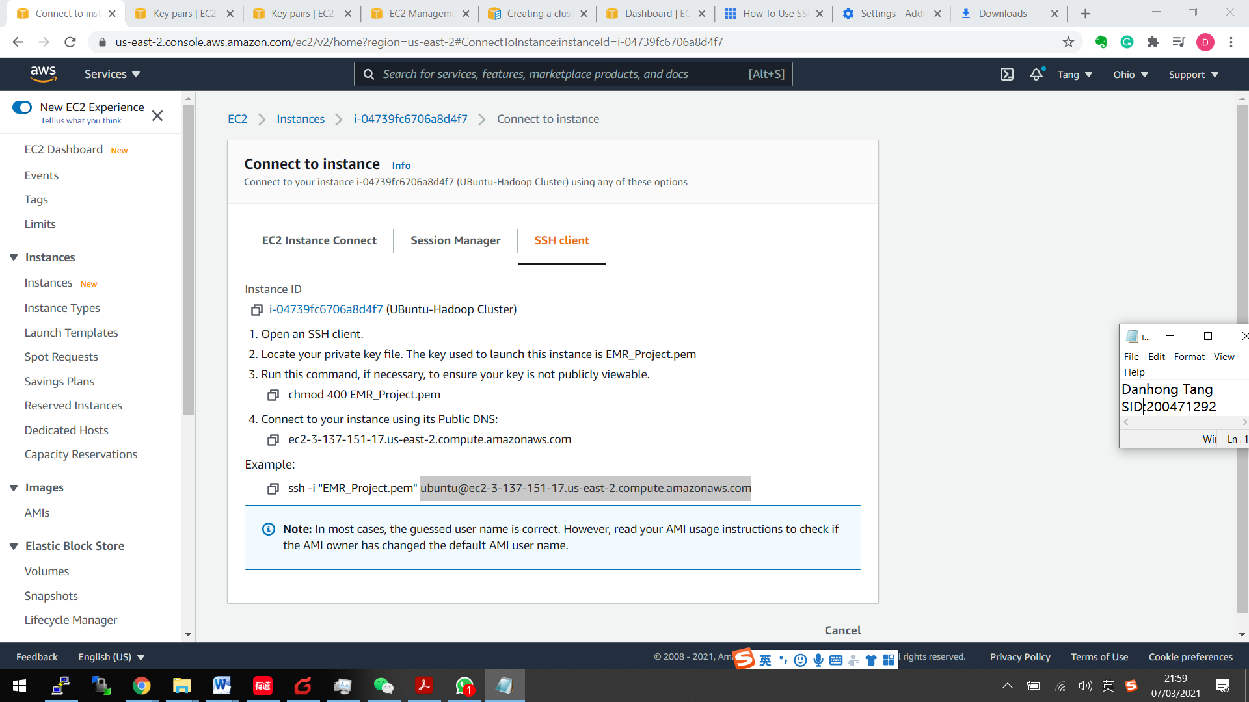

Update db:

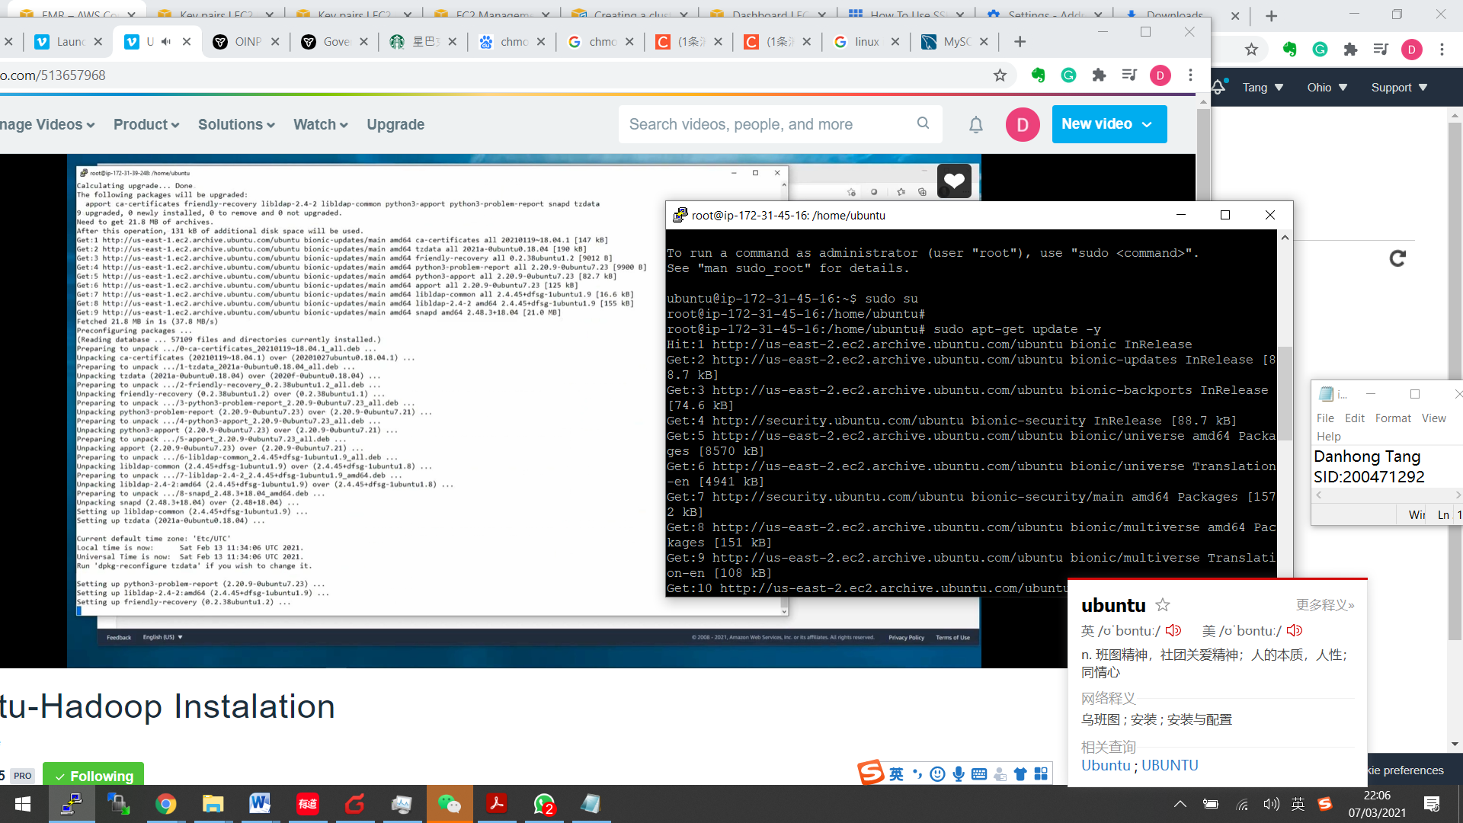

Finish visudo from nano:

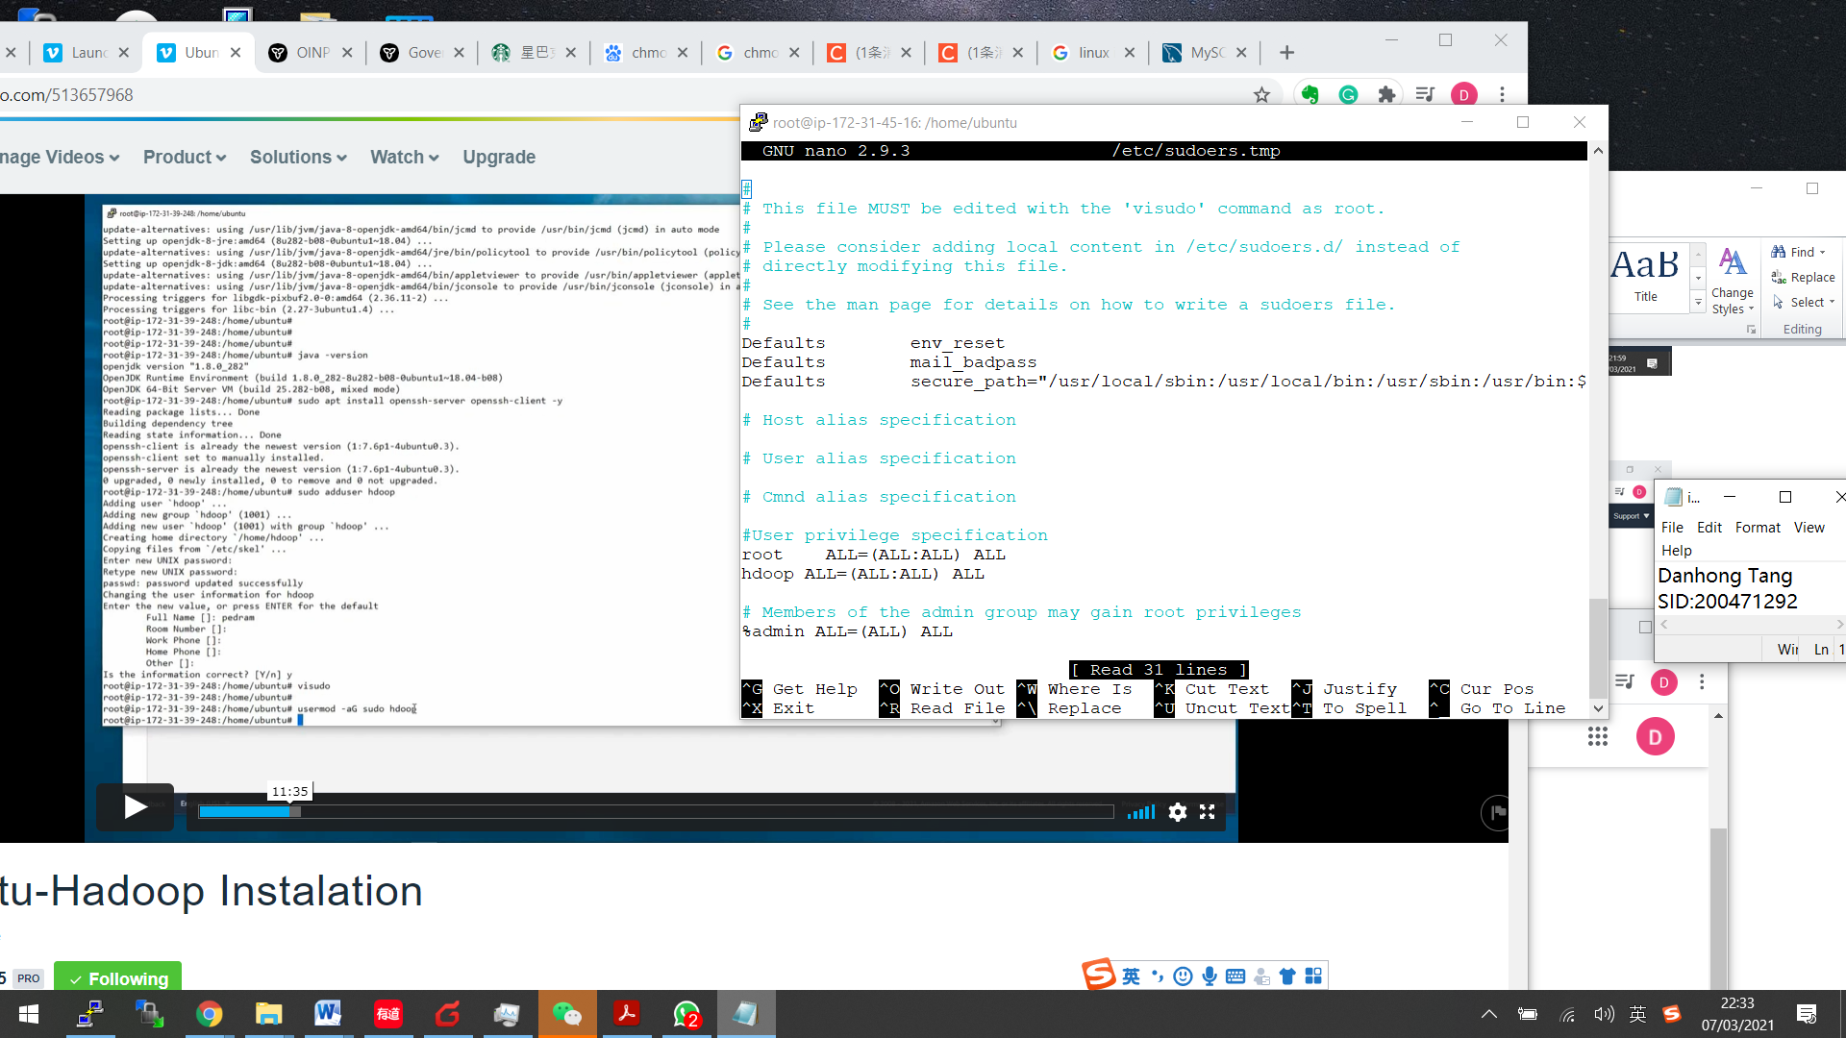

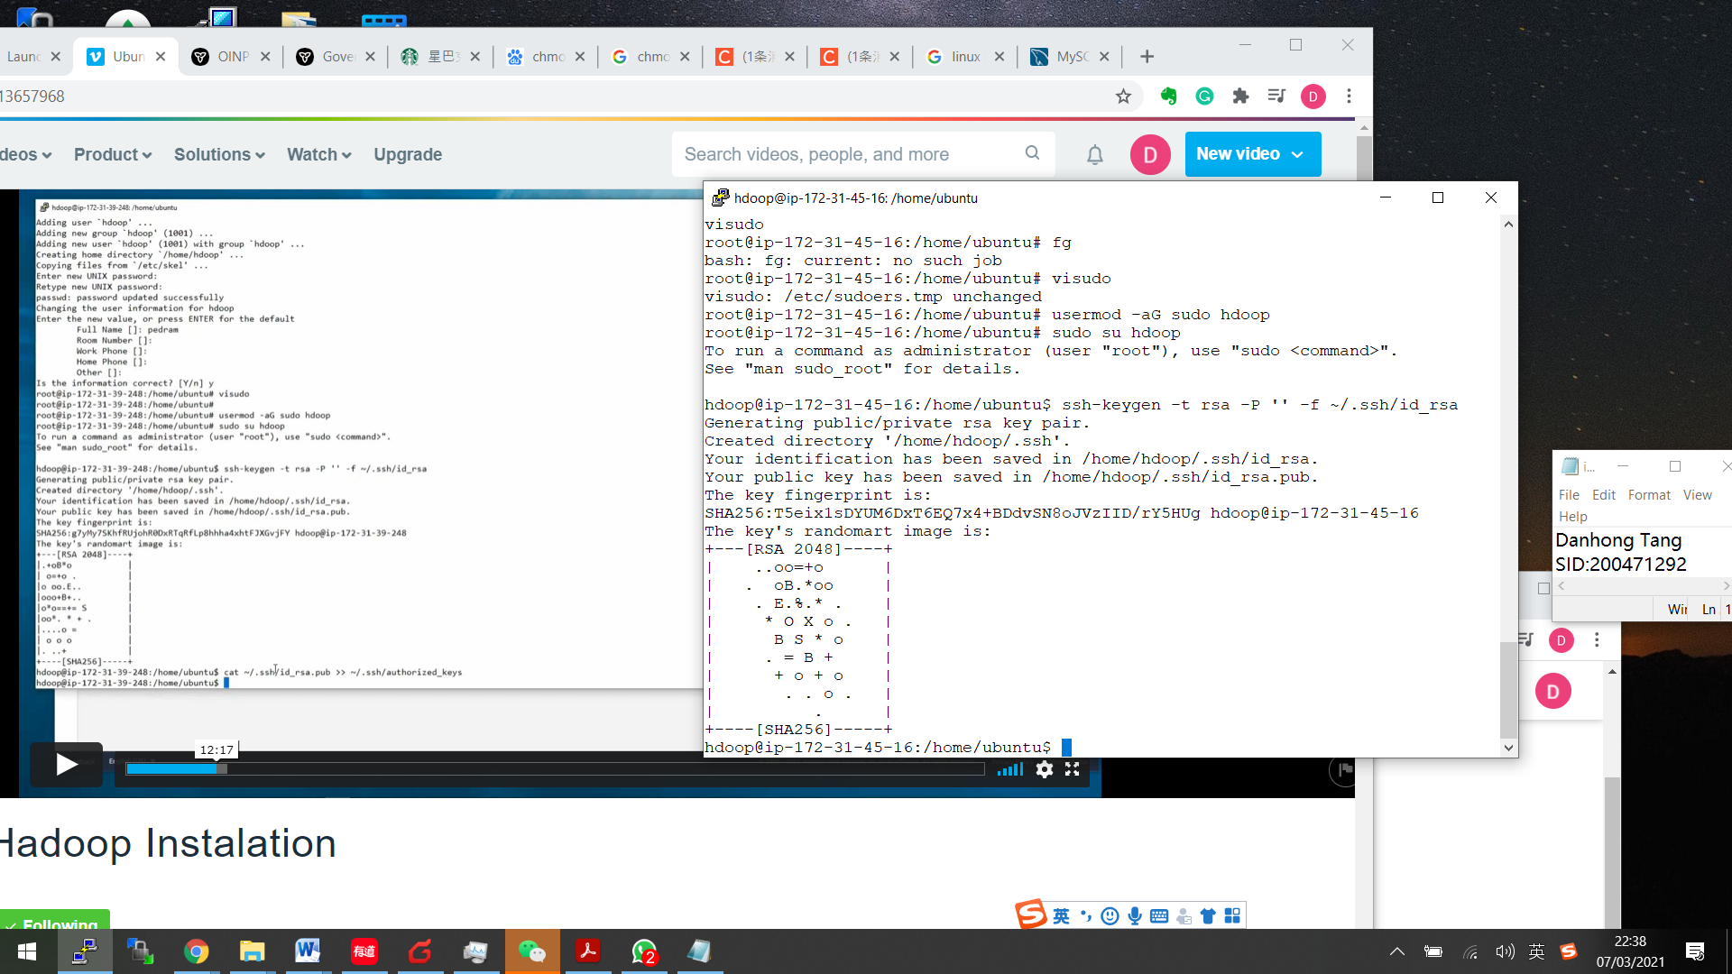

Download hadoop :

wget <https://mirrors.estointernet.in/apache/hadoop/common/hadoop-2.10.1/hadoop-2.10.1.tar.gz>

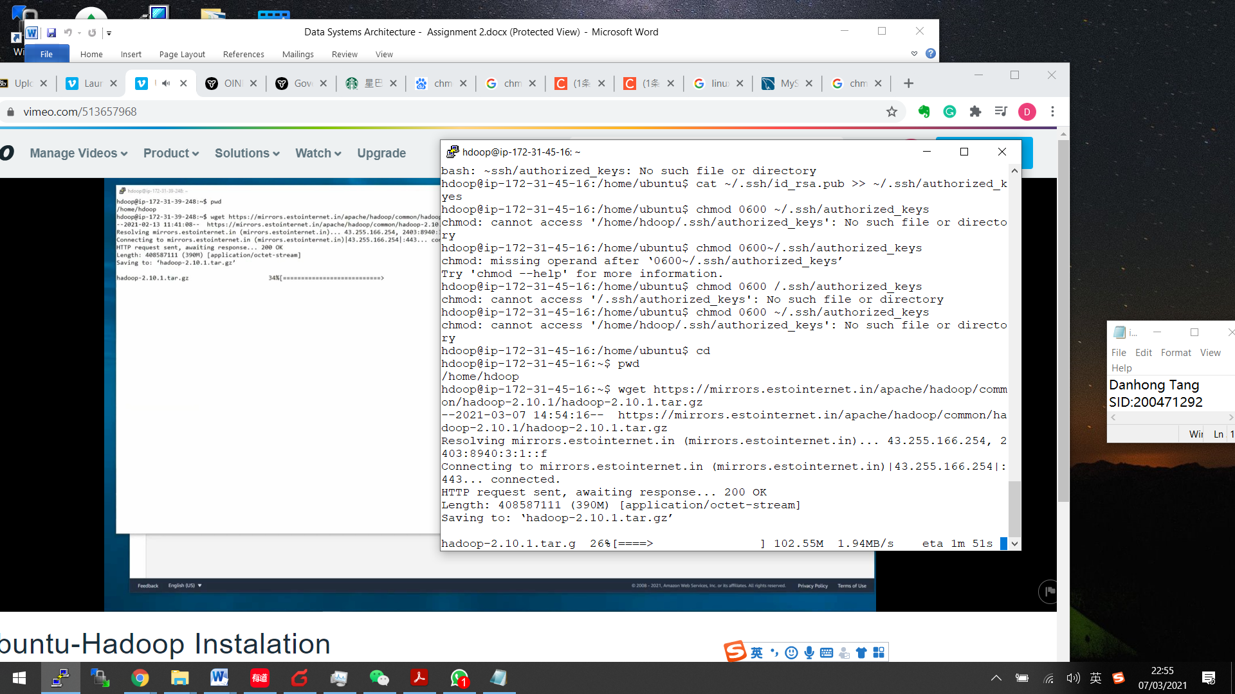

Check the setting is working:

d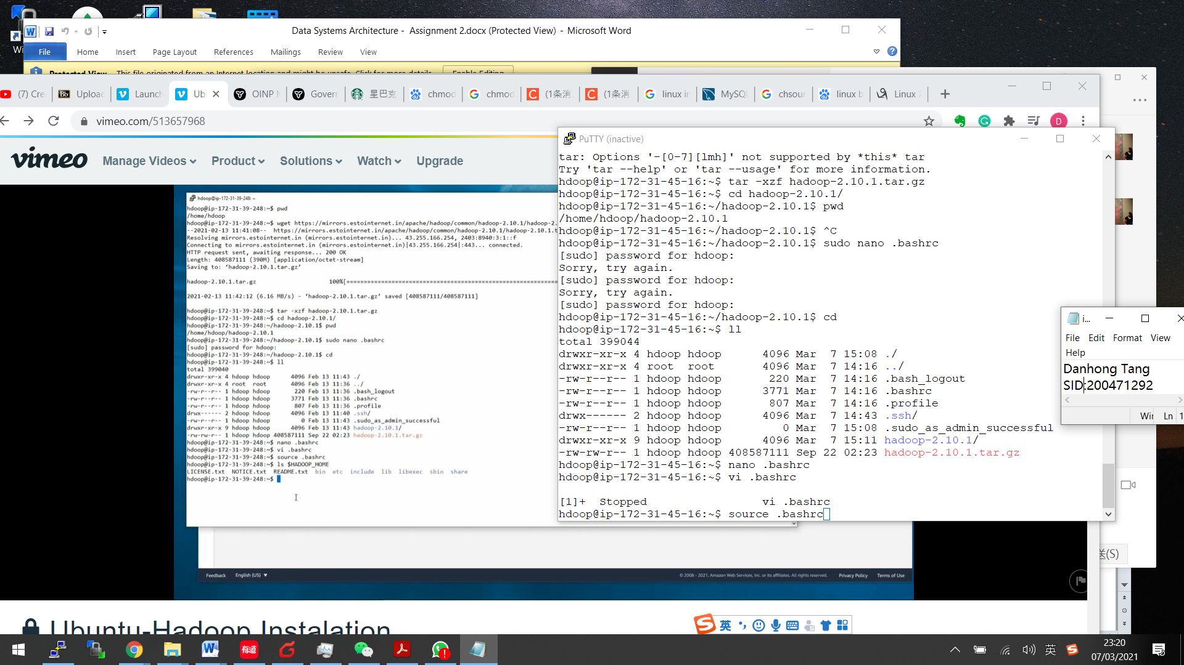

* source .bashrc

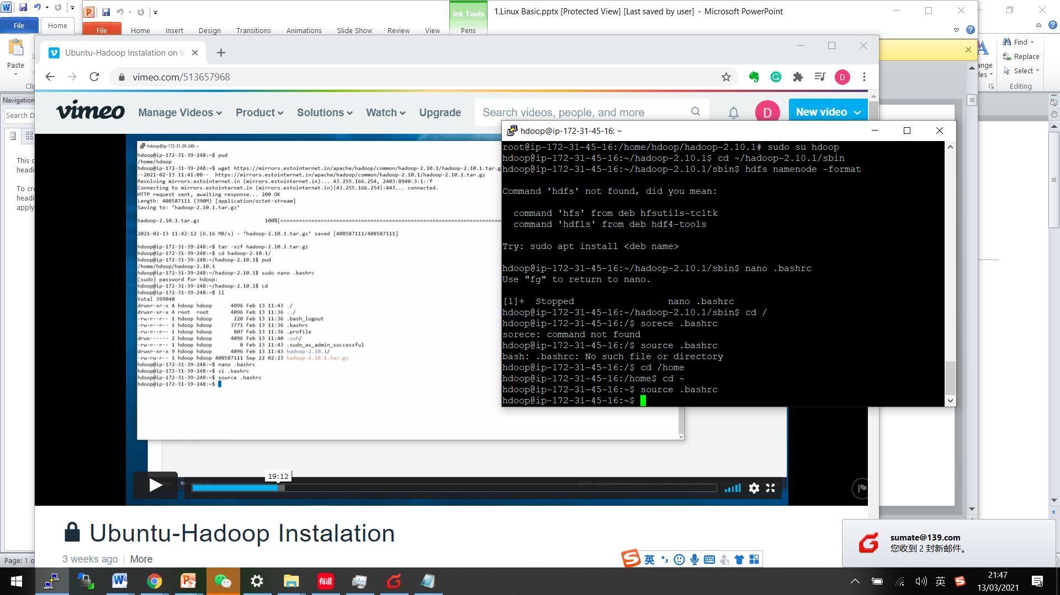

sudo nano $HADOOP_HOME/etc/hadoop/core-site.xml

sudo nano $HADOOP_HOME/ hadoop-2.10.1/etc/hadoop/core-site.xml

get info from EC2:

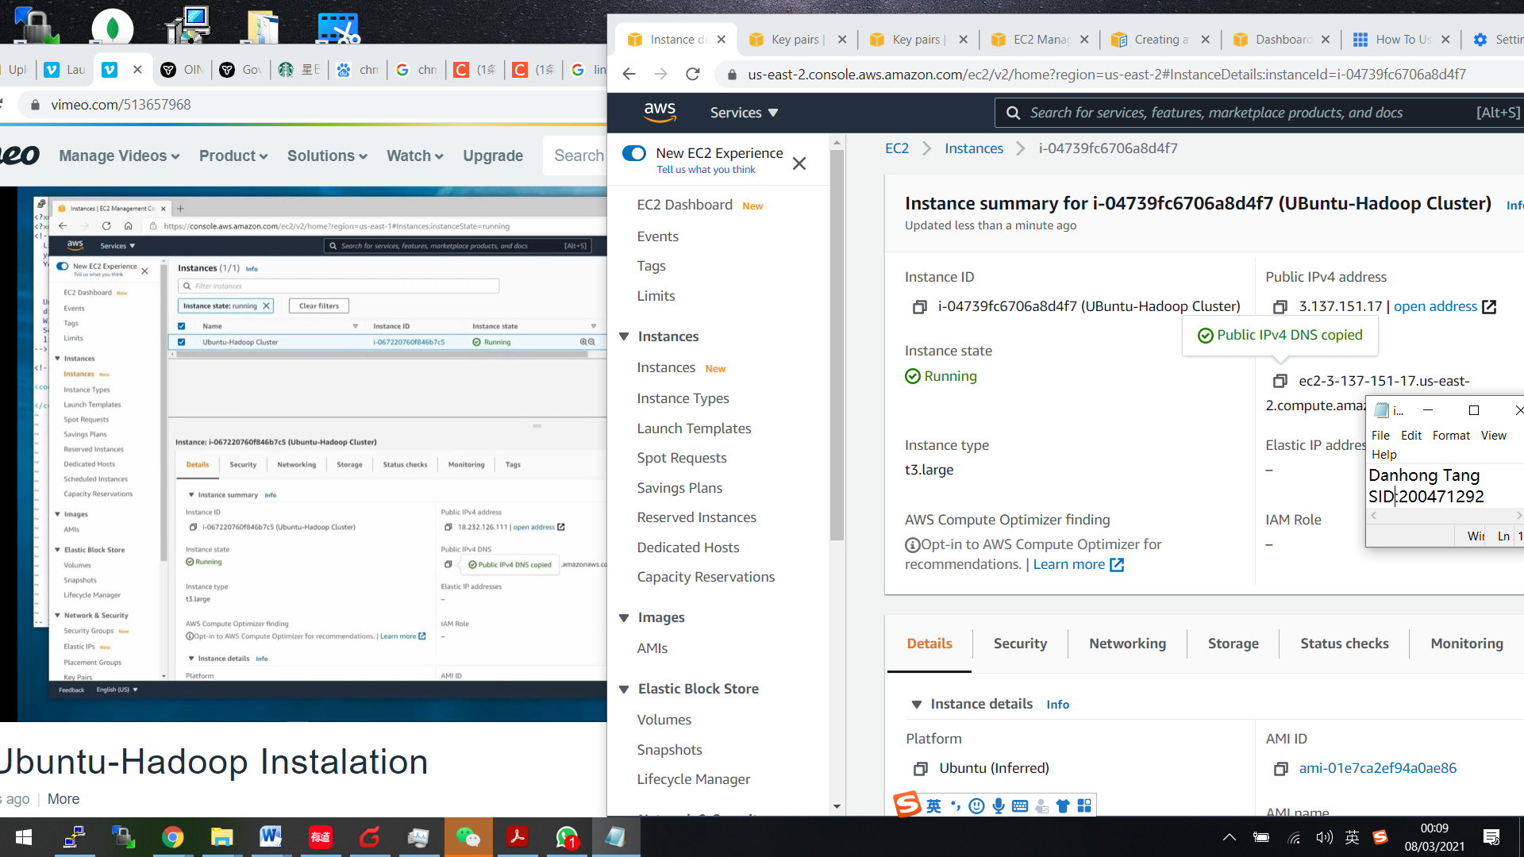

Using

**sudo nano $HADOOP_HOME/etc/hadoop/core-site.xml**

**sudo vi $HADOOP_HOME/etc/hadoop/core-site.xml**

to change core-site configuration:

<configuration>

<property>

<name>hadoop.tmp.dir</name>

<value>/home/hdoop/tmpdata</value>

</property>

<property>

<name>fs.default.name</name>

<value>dhfs://ec2-3-137-151-17.us-east-2.compute.amazonaws.com:8088</value>

</property>

</configuration>

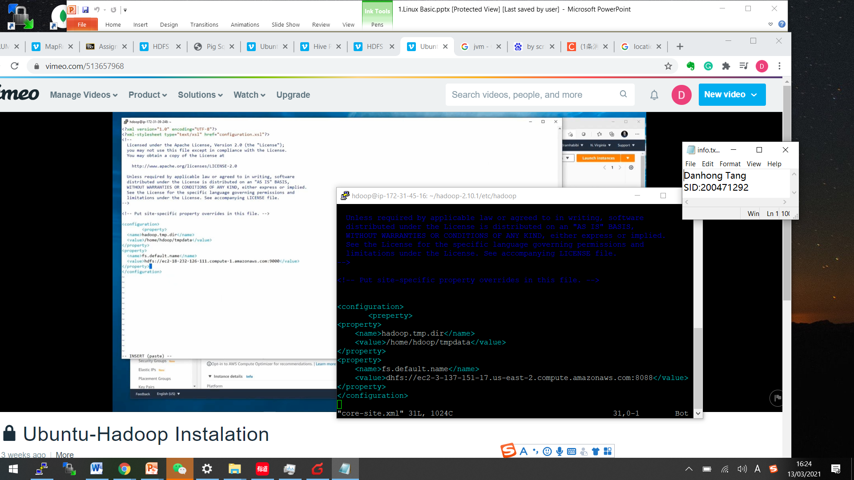

* **sudo vi hdfs-site.xml**

<configuration>

<property>

<name>dfs.data.dir</name>

<value>/home/hdoop/dfsdata/namenode</value>

</property>

<property>

<name>dfs.data.dir</name>

<value>/home/hdoop/dfsdata/datanode</value>

</property>

<property>

<name>dfs.replication</name>

<value>1</value>

</property>

<configuration>

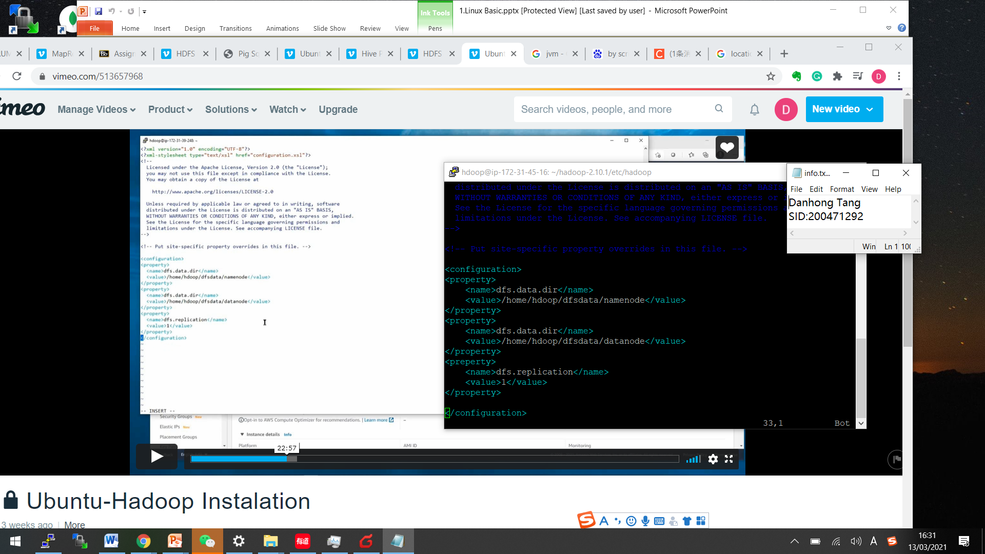

* **vi mapred-site.xml**

<property>

<name>mapreduce.jobtracker.address </name>

<value>ec2-3-137-151-17.us-east-2.compute.amazonaws.com:8088 </value>

</property>

<property>

<name>mapreduce.framework.name </name>

<value>yarn</value>

</property>

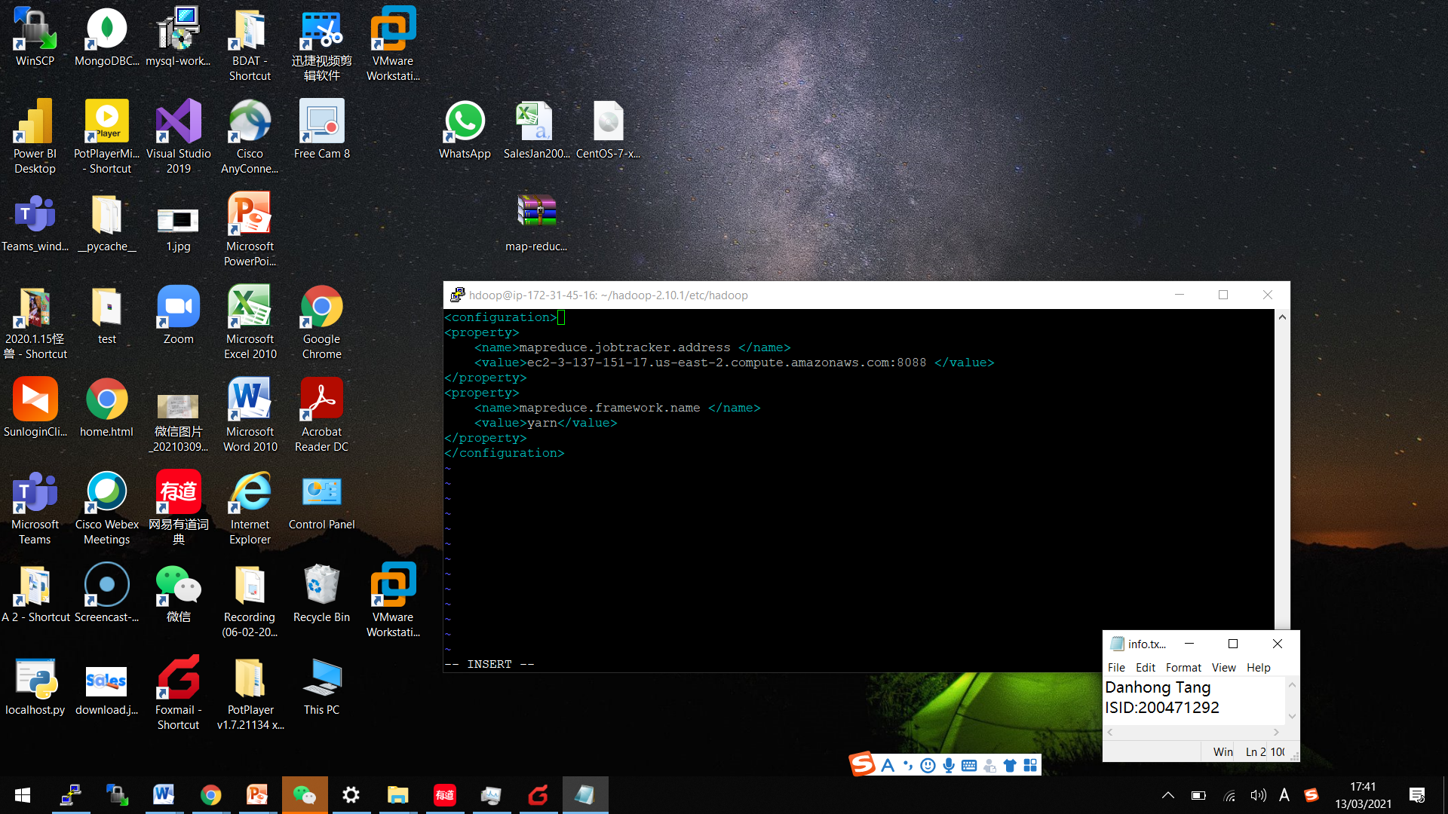



<property>

<name>yarn.nodemanager.aux-services </name>

<value>mapreduce_shuffle </value>

</property>

<property>

<name> yarn.nodemanager.aux-services.mapreduce.shuffle.class</name>

<value>org.apache.hadop.mapred.ShuffleHandler</value>

</property>

<property>

<name> yarn.resourcemanager.hostname </name>

<value>ec2-3-137-151-17.us-east-2.compute.amazonaws.com </value>

</property>

<preperty>

<name> yarn.acl.enable </name>

<value>0 </value>

</property>

<property>

<name> yarn.nodemanager.env-whitelist </name>

<value>JAVA_HOME,HADOOP_COMMON_HOME,HADOOP_HDFS_HOME,HADOOP_CONF_DIR,CLASSPATH_PERPEND_DISTCACHE,HADOOP_YARN_HOME,HADOOP_MAPRED_HOME </value>

</property>

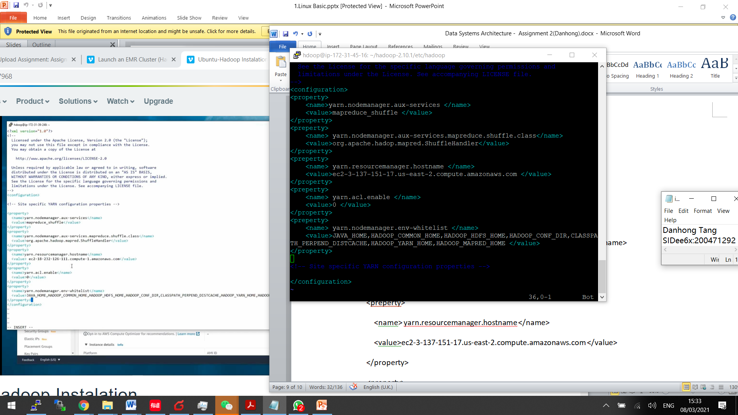

* vi hadoop-env.sh

Change JAVA_HOME=/usr/lib/jvm/java-11-openjdk-amd64

ls /usr/lib/jvm/java-11-openjdk-amd64

I could not save my modification for many times, until I used this one:

After modification, please press ESC and the given command :x!.

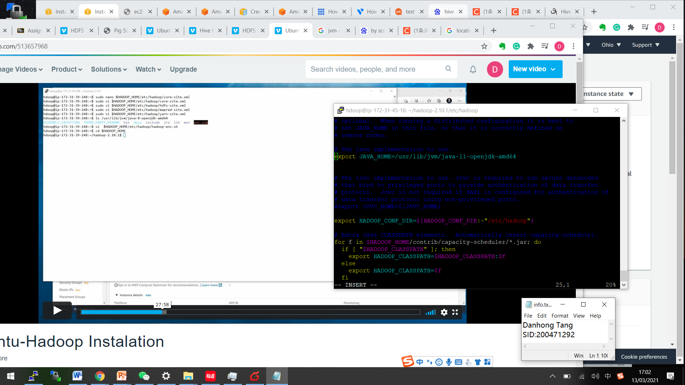

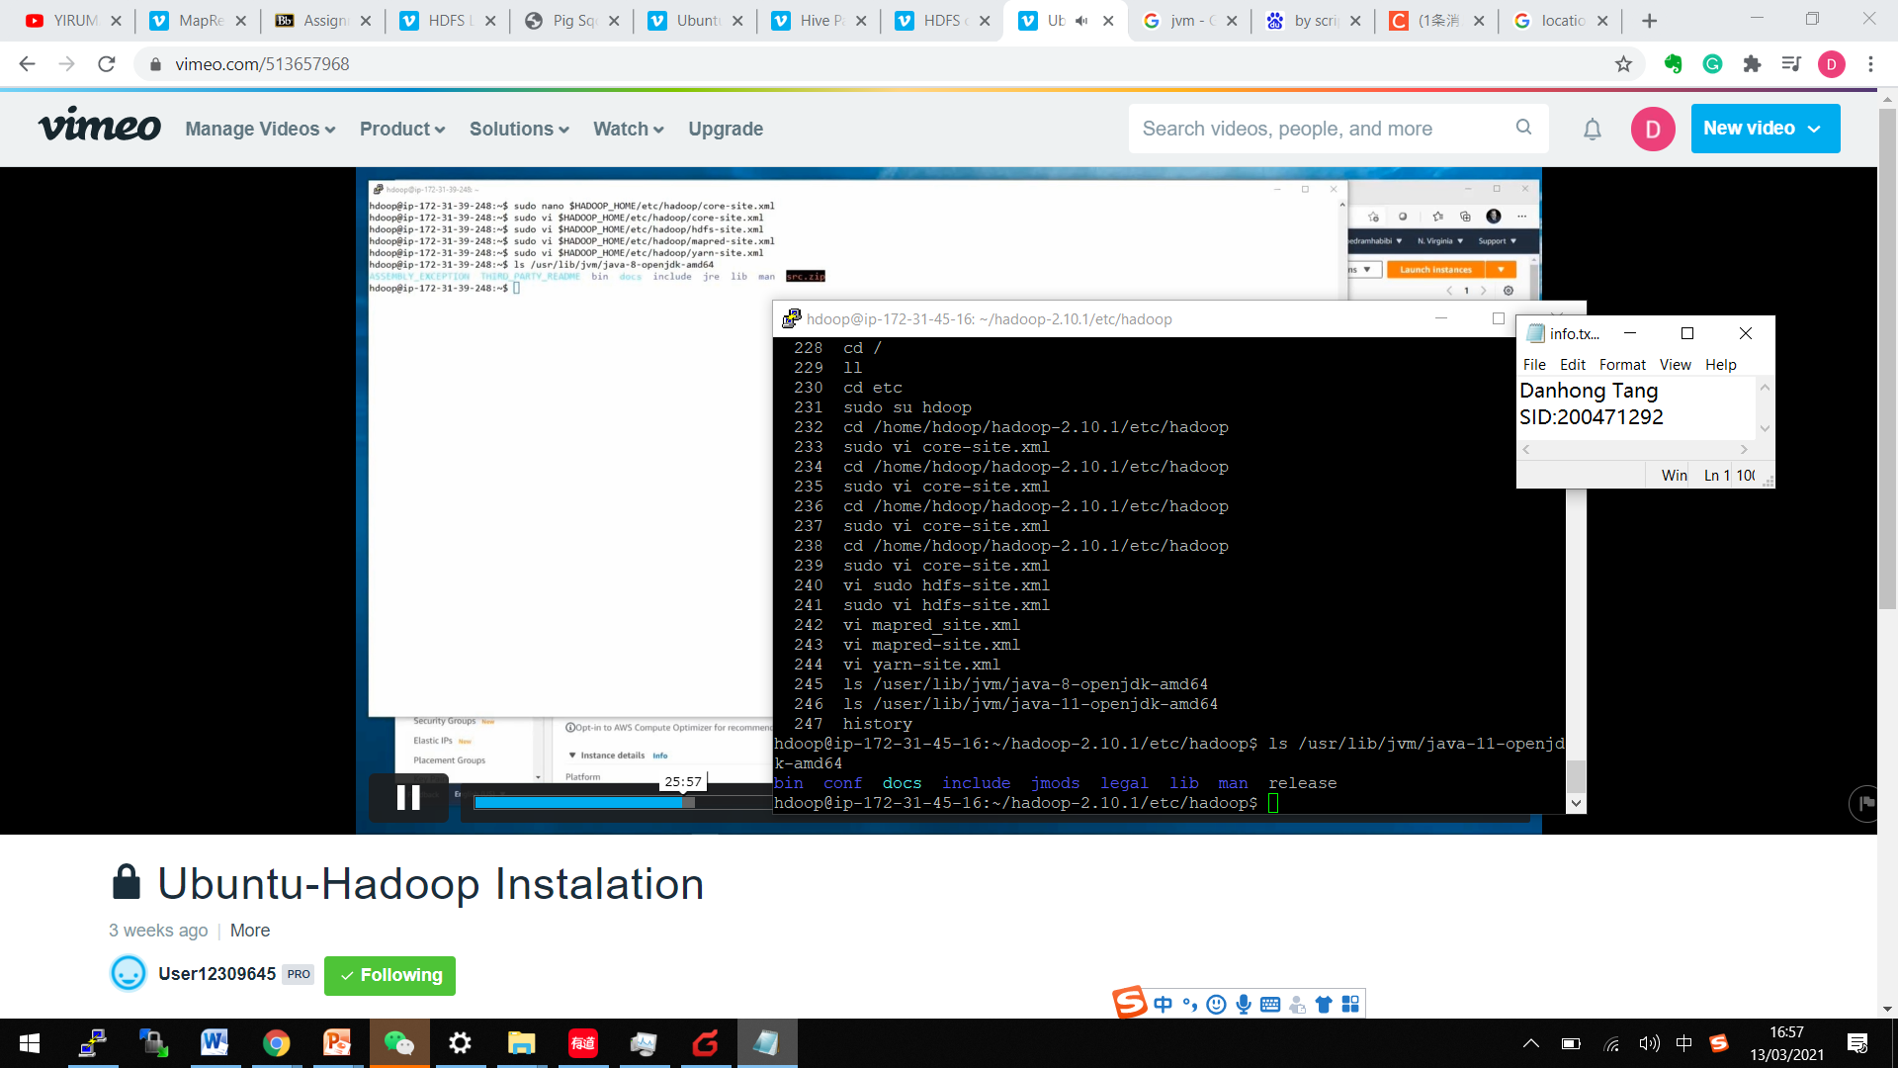

* ./start-dfs.sh

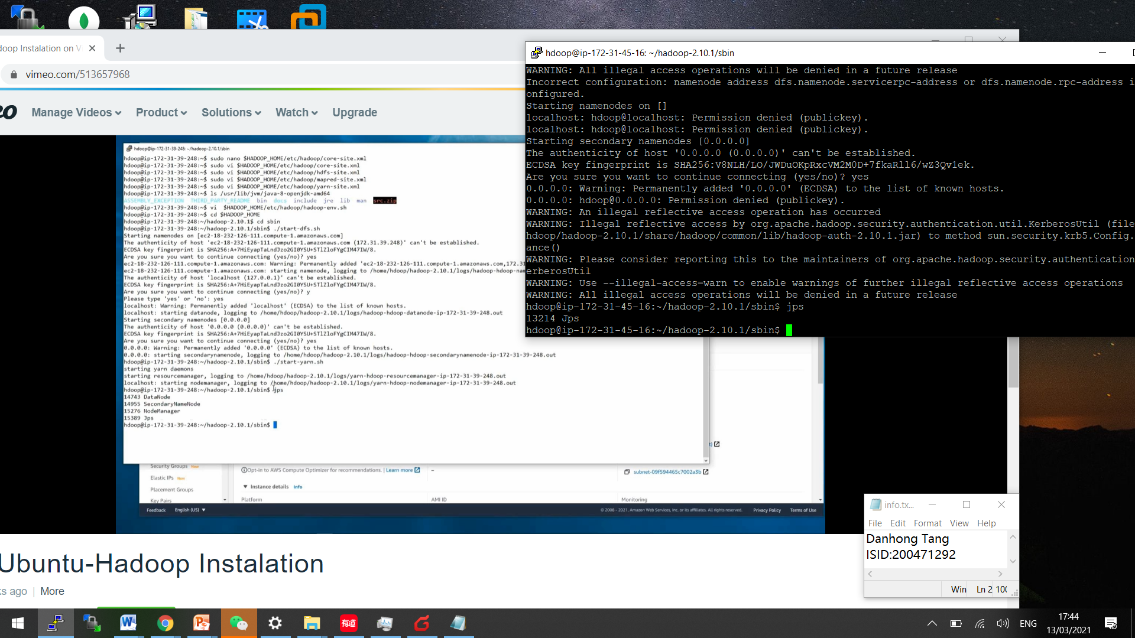

* Load namenode, but I met this problem:

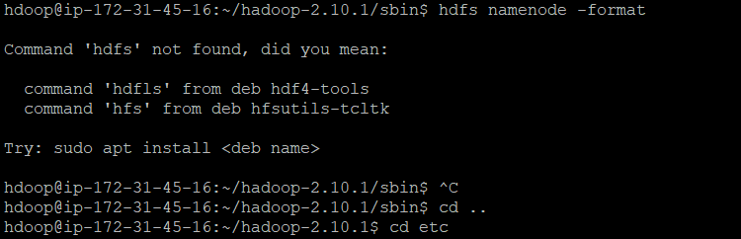

* Fixed it through adding and exporting PATH , then “resource” the file

Export PATH=$PATH:$HOME/bin:$JAVA_HOME/bin:$HADOOP_HOME/bin:$HADOOP_HOME/sbin

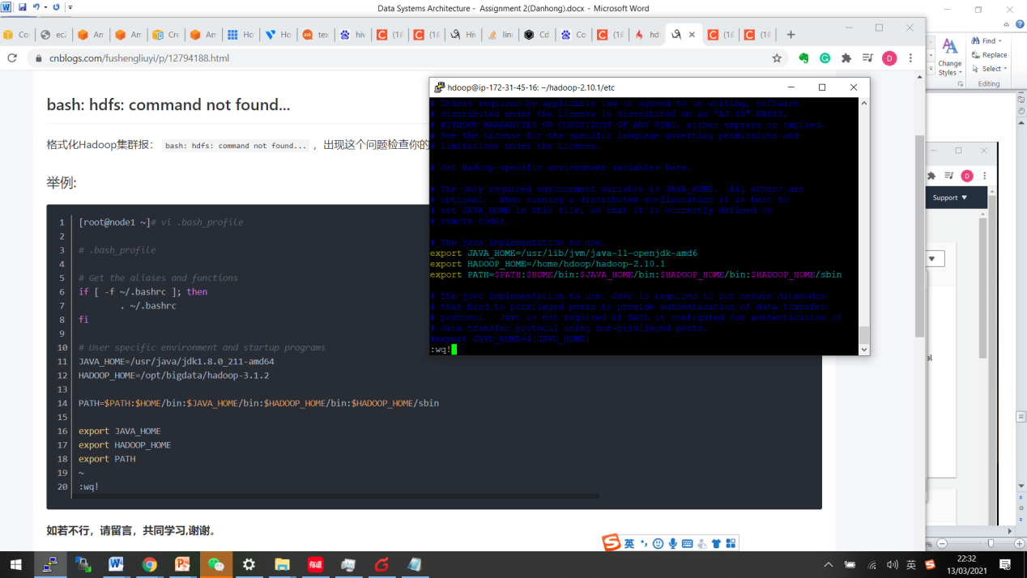

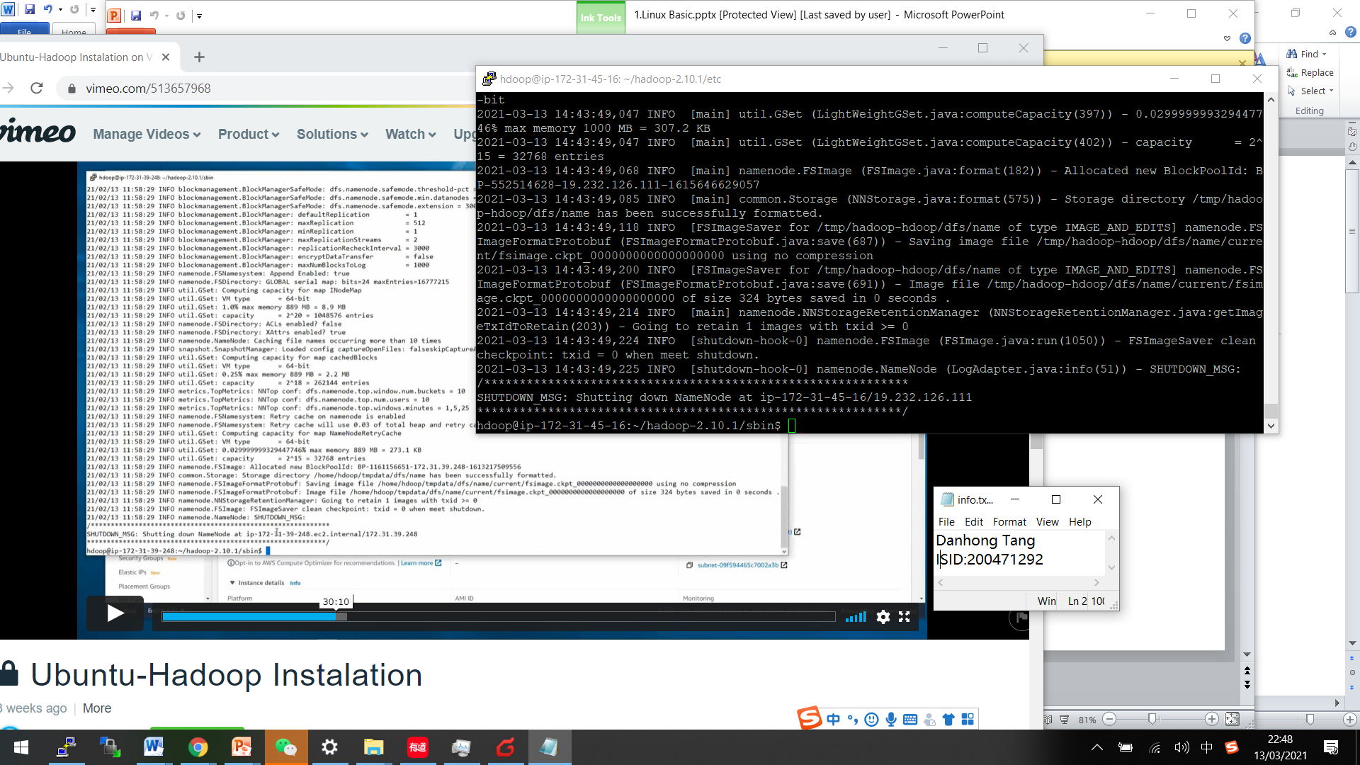

* Update host file

Check local host: 127.0.0.1

3.137.151.17 ip-172-31-45-16

127.0.0.1 localhost

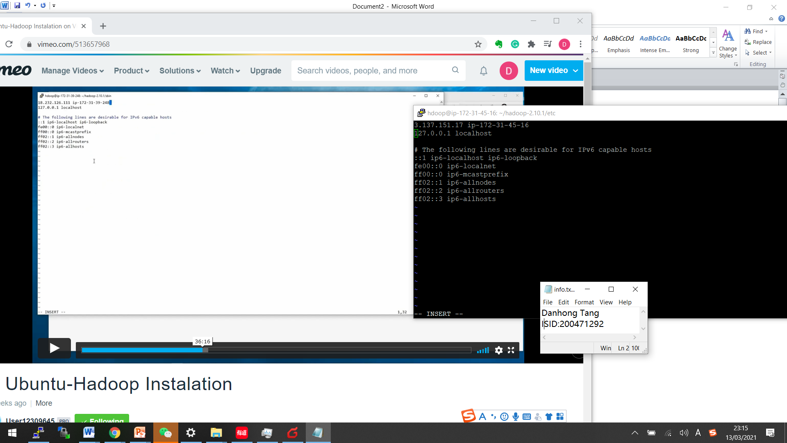

* ./start-dfs.sh

Error again 

Fix by “sudo vi hadoop-env.sh”

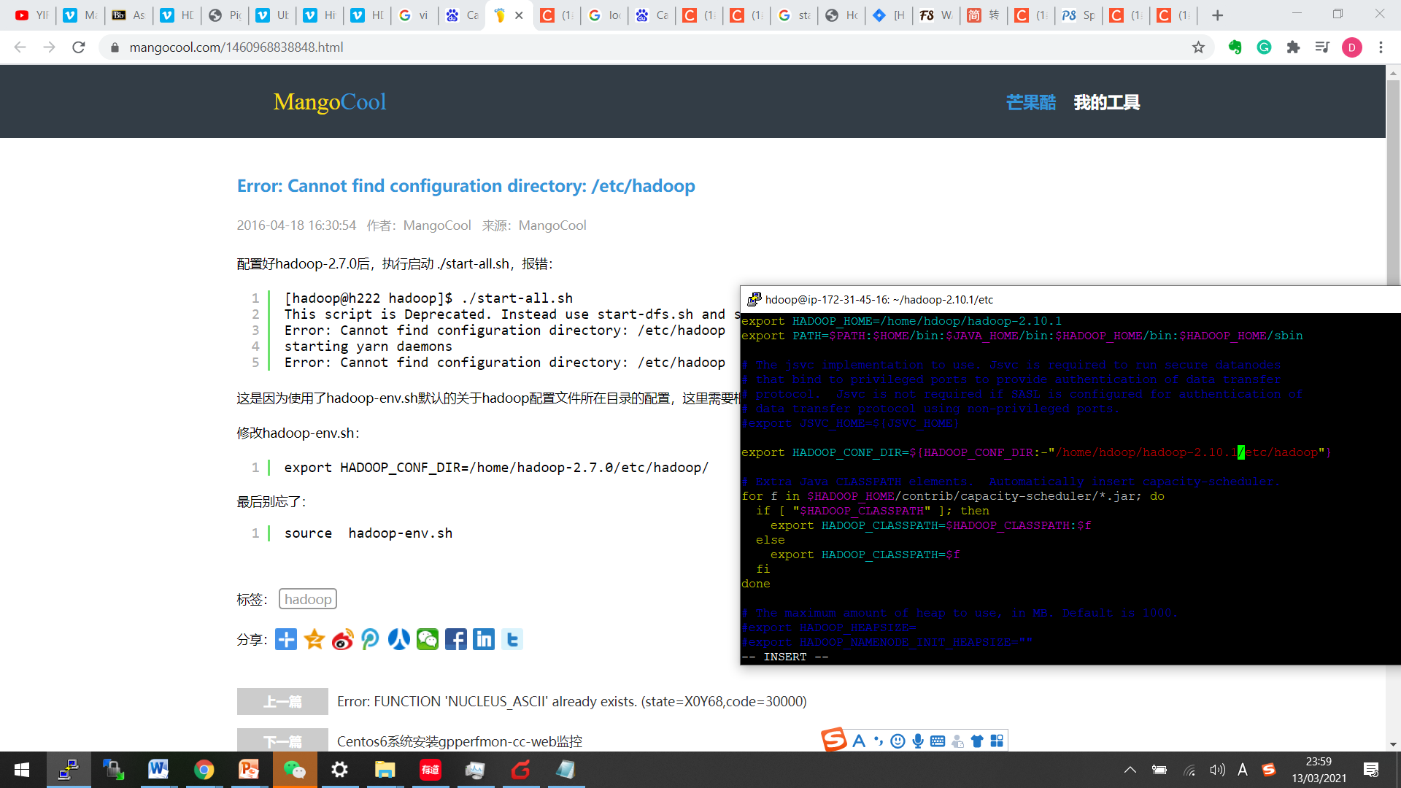

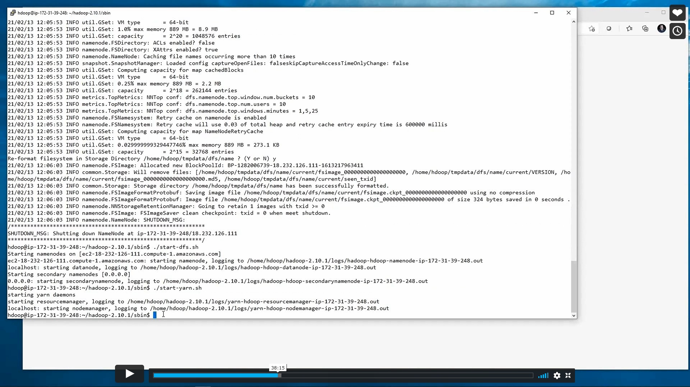

* Still cannot “./start-dfs.sh”,so need to remove JAVA 11 and install JAVA 8

<https://askubuntu.com/questions/1157219/removing-jdk-11-to-jdk-8>

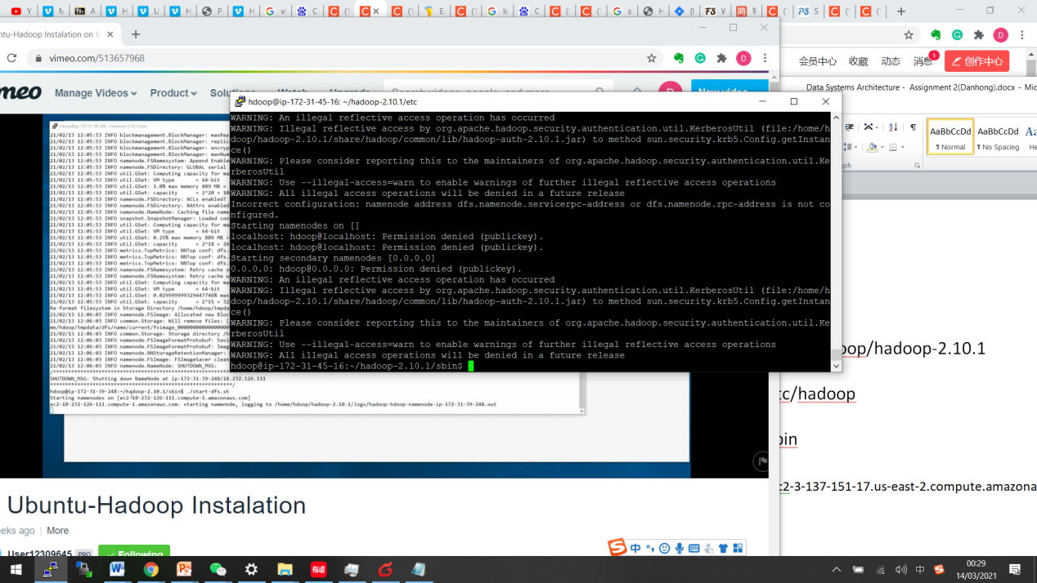

* Still cannot “./start-dfs.sh”,so need to change SSH key

<https://stackoverflow.com/questions/64342257/i-keep-getting-permission-denied-in-google-cloud-terminal-when-trying-to-open>

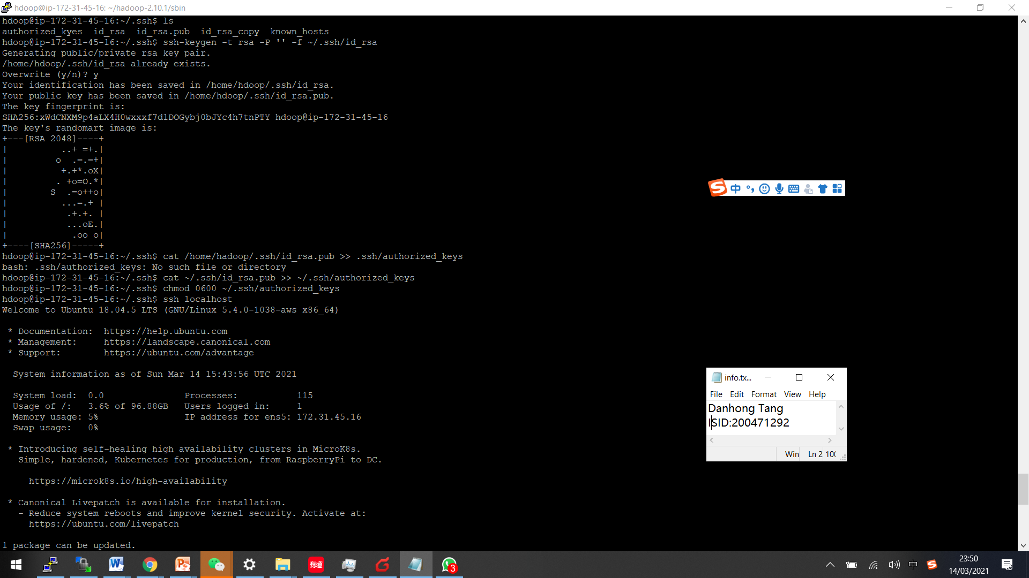

* “./start-dfs.sh”works! but cannot “dfs ls”

